Nepal College of information Technology
Imadol lalitpur
Unit Test Fall Semester 2005/2006

Program : BE Semester: I
Time : 2hrs Year : I
Engineering Math-I

Attempt all the questions

1. Integrate any three:- 5*3=15
i. 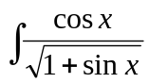dx ii. 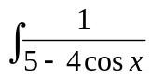dx
iii. 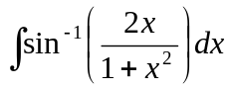 iv. 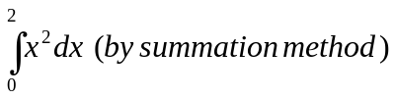
2. a. Prove that 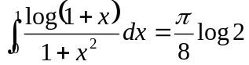 8

Or
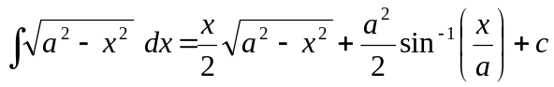
b. Find the area bounded by the curve y² = 4x and the line y = x. 7
3. a. Find the volume of the solid in the region bounded by the curve y = x² + 1 and the line y = -x + 3 revolved about the x-axis. 8
b. Find the arc length of the curve 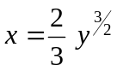 from y =1 to y = 2. 7
4. a. Approximate the integral 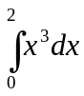 with n =4 using i) Trapezoidal rule b) Simpson's rule. c) exact value 9

b. i) Write any two properties of definite integrals
ii) Trace the curve y = x² + 4x. 6

Nepal College of information Technology
Imadol lalitpur
Unit Test Fall Semester 2005/2006

Program : BE Semester: I
Time : 2hrs Year : I
Engineering Math-I

Attempt all the questions

1. Integrate any three:- 5*3=15
i. dx ii. dx
iii. iv.
2. a. Prove that 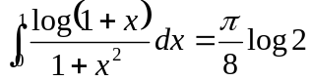 8

Or
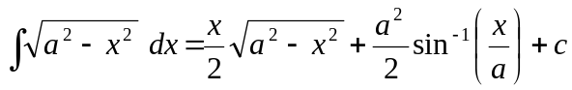
b. Find the area bounded by the curve y² =4x and the line y = x. 7
3. a. Find the volume of the solid in the region bounded by the curve y = x² + 1 and the line y = -x + 3 revolved about the x-axis. 8
b. Find the arc length of the curve from y =1 to y = 2. 7
4. a. Approximate the integral with n =4 using i) Trapezoidal rule b) Simpson's rule. c) exact value 9

b. i) Write any two properties of definite integrals
ii) Trace the curve y = x² + 4x. 6

